You have 30 minutes to stop global warming and prepare for climate change.

Split into groups and map out the following factors:

- energy supply
- transportation
- building infrastructure
- industry

- human dislocation
- food supply /animal and plant migrations
- increased heat / florida
- disease vectors / education
- financing

Each item should be the synopsis of what it looks like in 2100.

At the end, each group has ~3 minutes to present their statement.

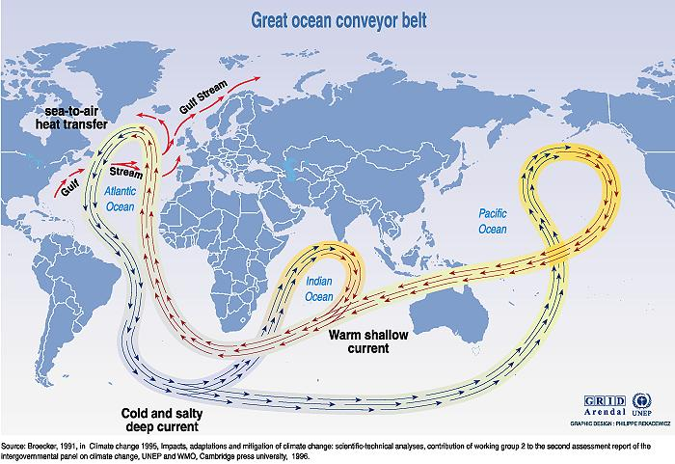

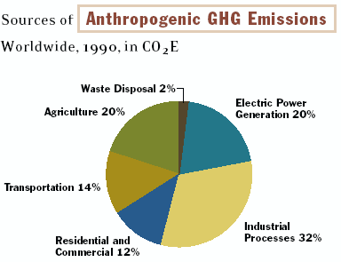 | 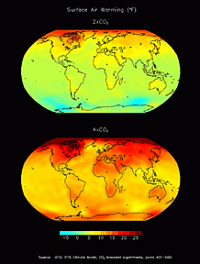  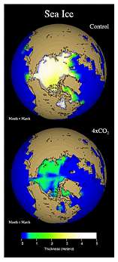
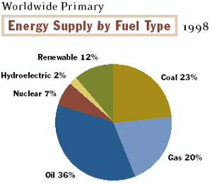

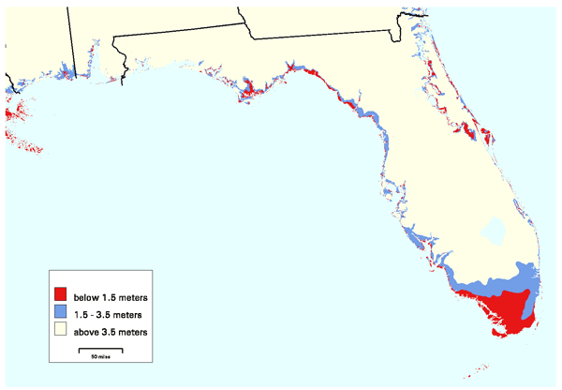

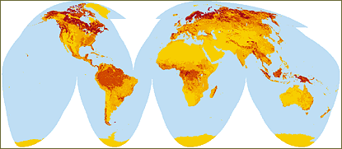

Global Carbon Storage in Above- and Below-Ground Live Vegetation and Soils

