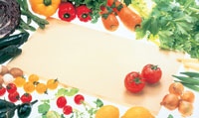

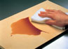

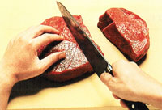

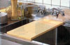

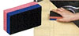

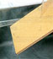

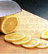



Asahi Cutting Board, # 1 in Hygiene!

Soft & flexible | No germs or smell | Durable material | Easy to handle
Knives stay sharper longer, while non-slip surface makes for safe cuts. | Composite rubber body repels moisture, mold resistant and very sanitary. | Hard to scratch, no plastic shavings, lasts up to 5 times longer than plastic based boards. | Soft to the touch, natural wood color, good grip, cleans with a soft cloth

This unique cutting board owes its popularity in Japan to the composite

