

Mark van Soestbergen
Gainesville City Commission
March 7, 2005
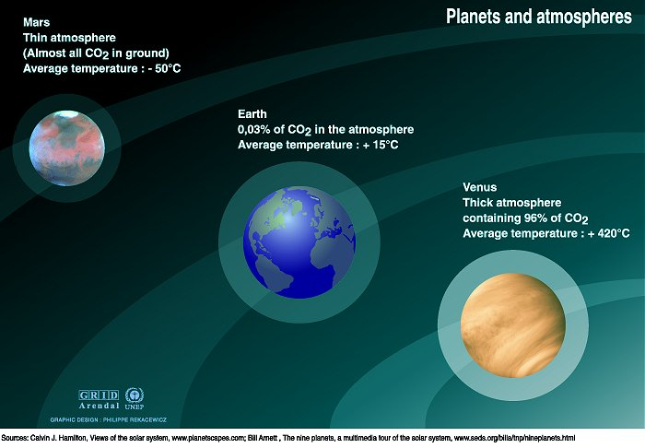

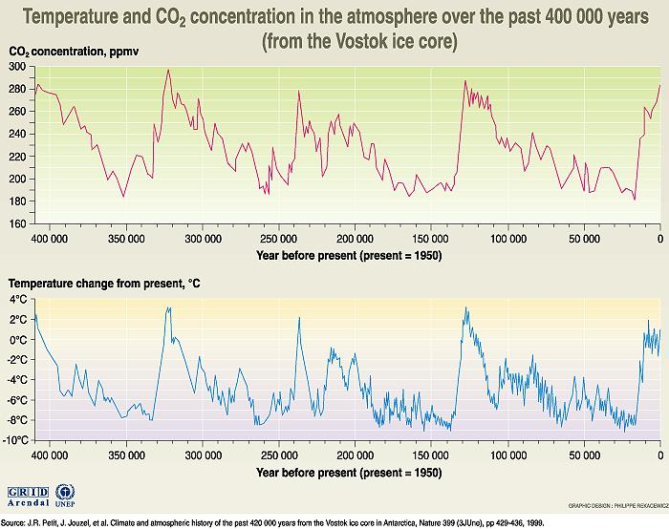

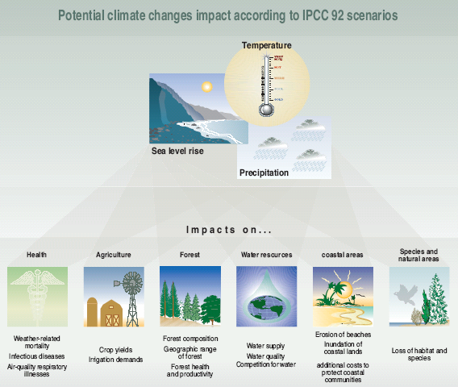

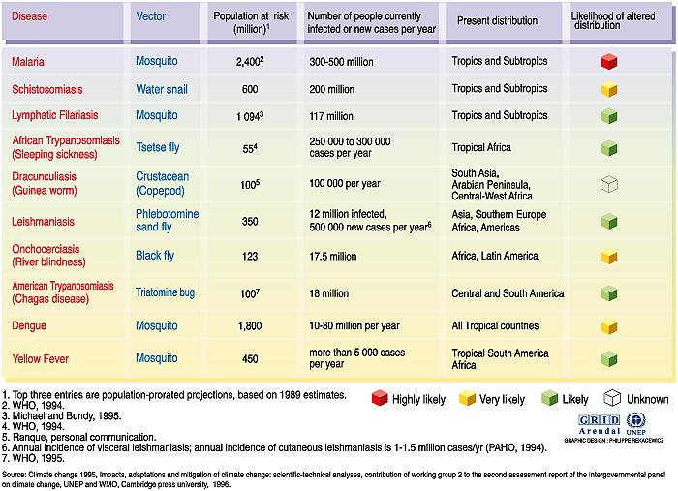
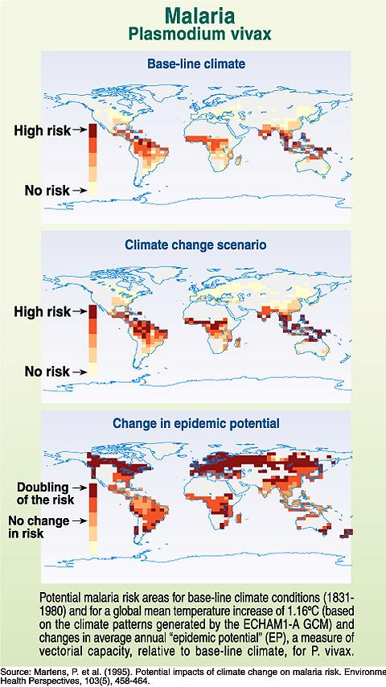 | 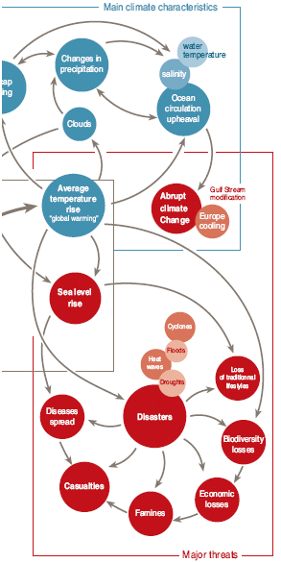

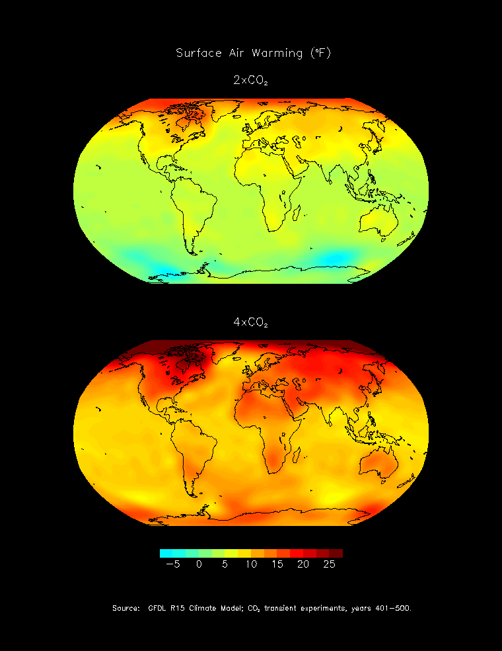 | 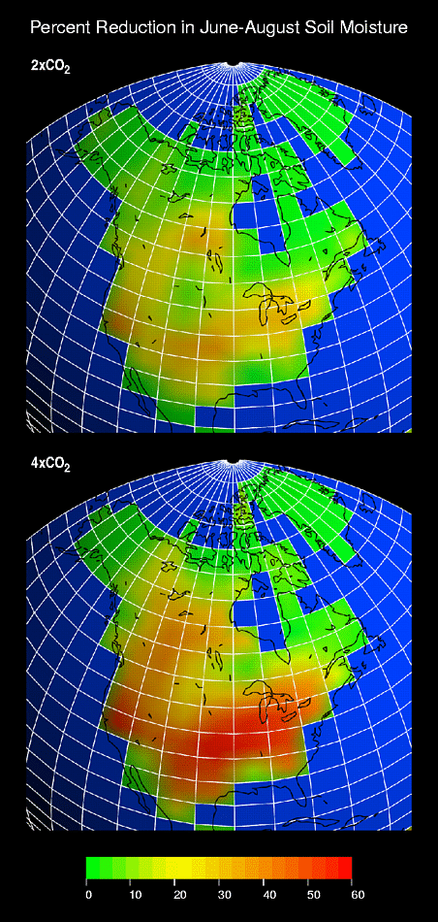

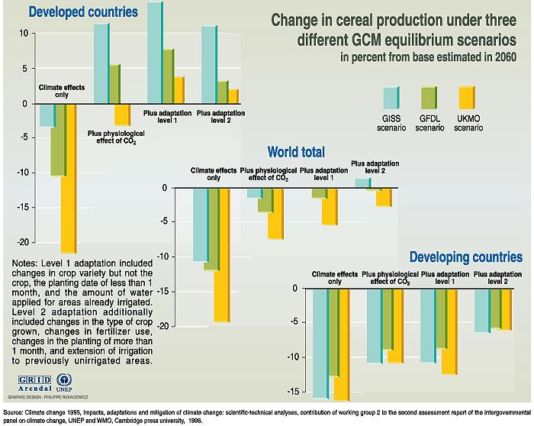

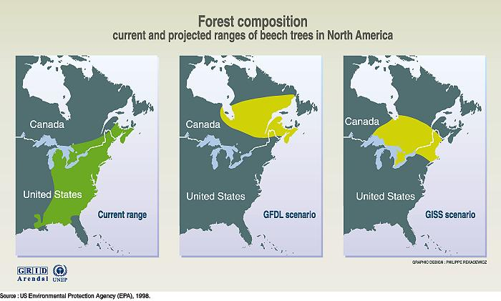

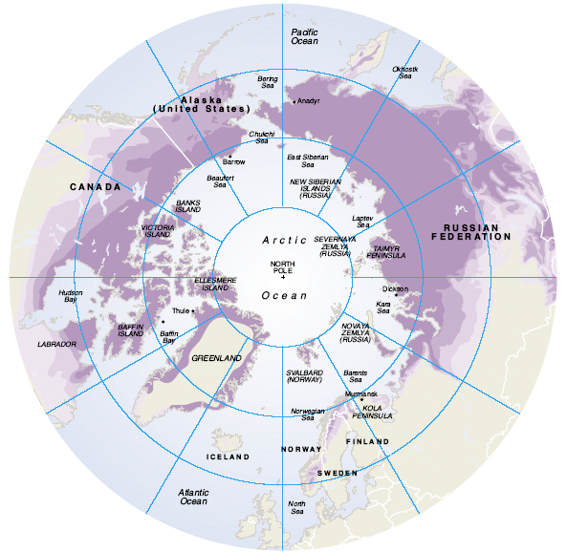

 | 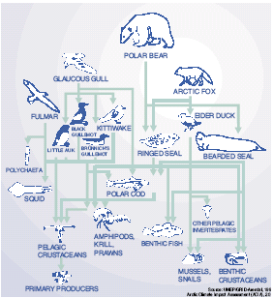

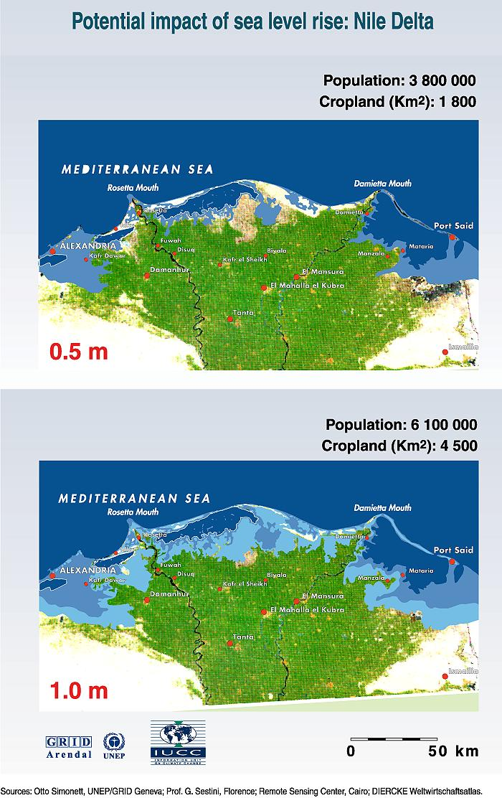 |   Chicago

Dacca

Paris

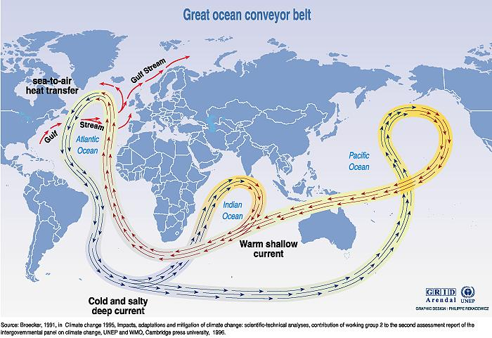

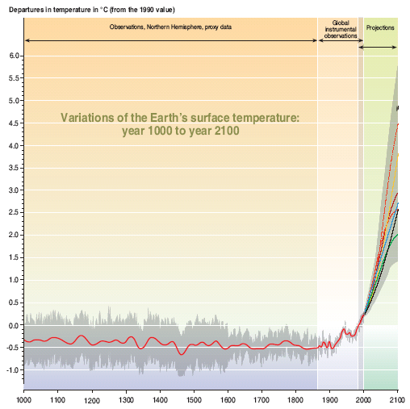
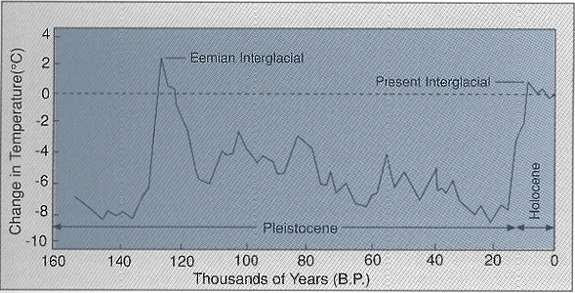
Notice that we are currently in the Holocene, and that man came out of his cave at the same time we entered the ‘present interglacial’ and started to flourish only after the 120,000 year winter was over.

Also observe the precipitous swings in temperature our planet is capable of.

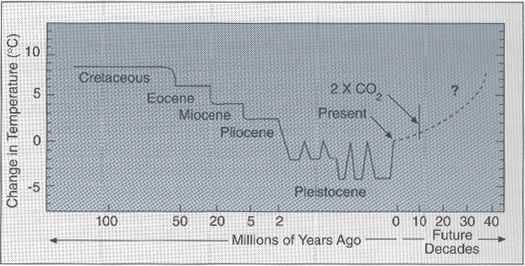

The key to this graph is understanding that CO2 is linked with geologic periods. In other words, if we travel to 4 x CO2, which some speculate we may later this century, we would travel across several geologic time zones. The 4 x scenario is not due to man’s emissions, but the sloughing off of equatorial and boreal biota when local conditions there change beyond a certain temperature threshold. Until now, we always thought man would be doing the increase in CO2, but as it turns out, nature can double our output (since 1750) in less than 2 decades. We will know in the coming few years what the likelihood of the 4 x scenario is. If the data starts showing that it is even 10% possible, it is imperative that this community prepares itself for a rapid transition to an unkown physical and economic world, while keeping an eye on such elements as local food production, water supply, new diseases and phenomenal weather events.
For the record.

I am not against coal, I’m against the incidental emissions of coal.

The trains that bring coal to Gainesville, go back empty. If we were really smart, we would put our waste wood into them, and have the miners store it underground. Then we would get carbon credits & create value on the return trip.

10 years from now, every Fortune 500 will have a Chief Climate Officer, or CCO.

Renewable energy is the new it, more money will be made in one decade in this sector than in 2 decades in the IT sector.

China will have more renewables than the US in less than 5 years from now.

The entire financial construct of plan A was between carbon, less carbon and rented carbon. This is akin to a business plan that presumes all servers will either use Microsoft, less Microsoft, or rented Microsoft, while glossing over the fact that a 21 year old dude named Linus created the most popular server software in his attic, now with global market share of 37%, in less than 3 years.

As a shareholder in a utility, I am surprised that the fact that legislation is before congress today that could make the CO2 emissions of plan A legally impossible, did not even get one bullet, out of the 18 months, hundreds of staff hours and 23.8MB of submitted information. If this legislation passes after we build the plant, we’d have to abandon it.

From a business perspective, I’d say we have a problem if a half billion $ decision fails to articulate or even muse about both the near term market fundamentals and potential long-term regulatory barriers.

I suspect some bias exist in the current utility management that may be financially unhealthy for both ratepayers and anticipated transfer.

I think we will have a new Manager of Utilities within a year, not because this one is not a nice guy, but this one simply doesn’t recognize the changing landscape.

We will have 10,000 electric generators in our local grid by 2020.

We have more pressing issues than debating the technical merits of a modern coal plant. For example, how do we position ourselves so that we continue to make money in a decarbonizing economy?

