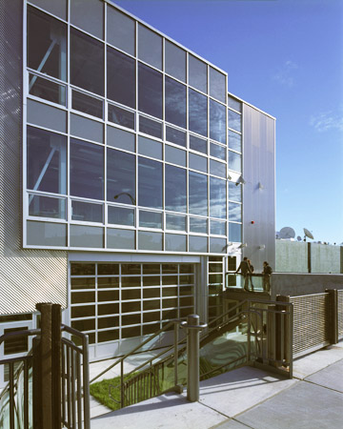
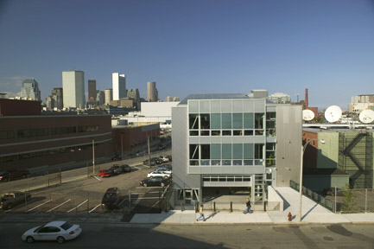

photos by Richard Mandelkorn

ARTISTS FOR HUMANITY EPICENTER
OPENS IN SOUTH BOSTON

Arrowstreet is Architect for Innovative Green Building

October 15, 2004
For Immediate Release:
Contact: Kathleen Leahy Born
617-623-5555

(Somerville, MA) The new Artists for Humanity EpiCenter, now open at 100 West Second Street at the edge of Boston’s Fort Point Channel Arts District, couples ingenious sustainable design with an innovative arts program in the South Boston Waterfront’s most distinctive new building project.

The new 22,500 square foot building, designed by architects Arrowstreet of Somerville, MA, is poised to receive a LEED Certification for Sustainable Design at the Platinum Level. the highest level awarded by the US Green Building Council. Special features include north and south-facing glass walls that provide passive heating and cooling as well as maximum utilization of daylight for interior lighting, building finishes and structural elements with a high content of recycled materials, water conserving fixtures, super insulation, exhaust fans and cross ventilation in lieu of an air conditioning system, and automatic dimming controls for energy-efficient light fixtures. The Massachusetts Technology Collaborative provided a grant for the rooftop photovoltaic array which generates 49.5 kilowatts of power for 60% of the building’s demand. Both NStar and KeySpan collaborated with rebates on energy efficiency technologies.

Artists for Humanity is a non-profit educational group founded in 1991 by Susan Rodgerson with the mission of bridging economic, racial and social divisions by providing at-risk youth with the keys to self-sufficiency through paid employment in arts. Arrowstreet was chosen in a competitive selection process because AFH wanted an architect who would not only design a unique building, but was willing, as a reflection of Artists for Humanity’s mentoring mission, to fully engage the students in every step of the design and construction process. “There is no doubt that our design was strengthened and enriched by the energy, and creative talents of the many young Boston artists who thrive in this unusual program,” says Jim Batchelor, Arrowstreet Principal and lead designer for this project.

The three story building, which makes use of many industrial idioms and materials, includes a ground level gallery space with mezzanine that accommodates groups as large as 800 people. A 24 foot wide garage door rolls up into the ceiling to connect the gallery to a grassy courtyard. Second level woodworking, silk screen, and graphic design studios share natural light through translucent corrugated wall panels. The third floor painting studio, with a dramatic thirty foot ceiling height, enjoys commanding views of the Boston skyline and benefits from natural daylight from sunrise to sunset. Even the rest rooms are unique with custom made curved metal and fiberglass stalls and long sloped stainless steel sinks, both custom-designed by a local artist.

Arrowstreet’s unique design for our new building truly represents who we are and what we do. It is a perfect reflection of our spirit of progressive action and our mission of developing creativity, entrepreneurship, and self sufficiency in young people,” says Susan Rodgerson, Artists For Humanity Executive/Artistic Director.

